Battalion chart
CSM
SGM Diego Nacionales
Battalion XO
MAJ Aubrey Arguello
C/BC
C/LTC Mason Bunyard

S1
1LT Canaan York

S2
SFC Zachary Winn

Color Guard
1LT April Maldonado
S3
2LT Emily Peña

S4
SSG Rosemary Powell

2nd Platoon SGT
SSG Allen
2nd Platoon Leader
SFC Gramke
1st Platoon SGT
SSG Steffens
1st Platoon SGT
SFC Aliyer
2nd Platoon Leader
2LT Fragger
1st Platoon Leader
2LT Gay
2nd Platoon Leader
2LT Thompson
1st Platoon Leader
2LT White
Alpha Company Commander 1LT April Maldonado
Bravo Company Commander
1LT Katleen Leosk
S6
2LT Richard Russell
S5
SGT Hailey James

Alpha 1
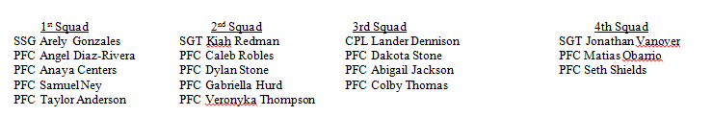
Alpha 2
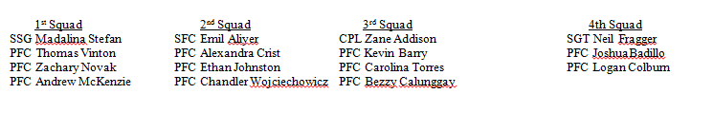
Bravo 1
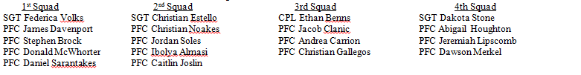
Bravo 2

